What we need? | Independent WebSite for SwadharmaServices
Swadharma Services Website | Account Adding Form (Panel) for SwadharmaSevices.in
Swadharma Services Website | Connect Payment Gateway via Vitta Fin, Check Access to an account via monthly payment of 49$ or annual payment of 499$. | Users may get discount.  First 10 Accounts will get  40% discount (31$PM or 360$PA)  Organisations will get additional coverage via Social Media and Swadharma Website ….
Account Holder 1) | DattaMukti.in – Independent Website
 | DattaMukti has subscribed to Swadharma Services | It has a subdomain swadharma.dattamukti.in
 | Populate these Links on the webpage.  Where to edit?  https://github.com/Dharma-Poshanam/dattamukti.in  Create pages and upload via GitHub. | 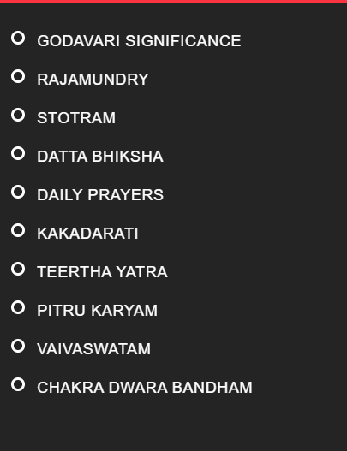
 |  | Swadharma.dattamukti.in
Account holder 2) | Dharma Poshanam subscribes | It gets swadharma.dharmaposhanam.in
 |  | New Payment Link to be configured to the gateway of account holder

